WD My Passport 1TB External USB 3.0 Portable Hard Drive - Black -

WDBYVG0010BBK (CZONE)

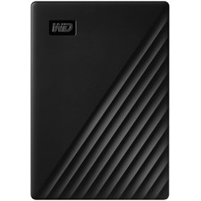

**Key Features**

* Storage: 1TB capacity to store large volumes of photos, videos, documents, and music.
* Connectivity: USB 3.0 interface for fast data transfer (up to 5 Gbps).
* Security: 256-bit AES hardware encryption with password protection.
* Backup Support: Compatible with WD Backup software for automatic backups.
* Design: Lightweight and portable, ideal for everyday use.

**Specifications**

* **Interface**: USB 3.0 (compatible with USB 2.0).
* **Dimensions**: 4.22 x 2.95 x 0.44 inches (L x W x H).
* **Weight**: 120 grams.
* **Color**: Black.

**Power Supply**

* Powered via USB connection; no external power source required.

**Box Contents**

* WD My Passport 1TB External Hard Drive.

**Warranty**

* 3-Year Limited Warranty.